# CSP Update for the Production Account

Use Cache Studio to import source code XML.

1. Save the VEFA_CSP_V_1_8.xml to your local drive.
2. Right click Cache Cube and select Studio.

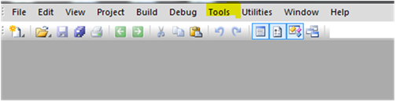

1. Select Cache Namespace for the production account where CSP source code will be imported.

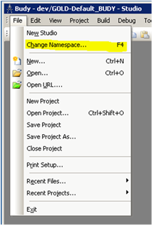

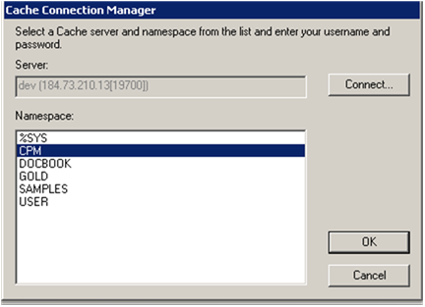

1. Click the **Tool** menu and select **Import Local**.

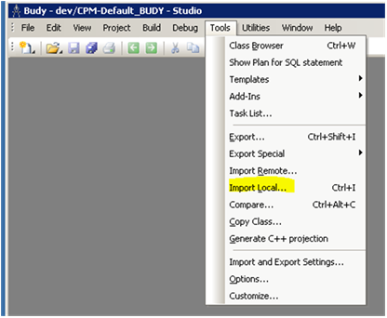

1. Find the VEFA_CSP_V_1_8.XML source code (for test account).

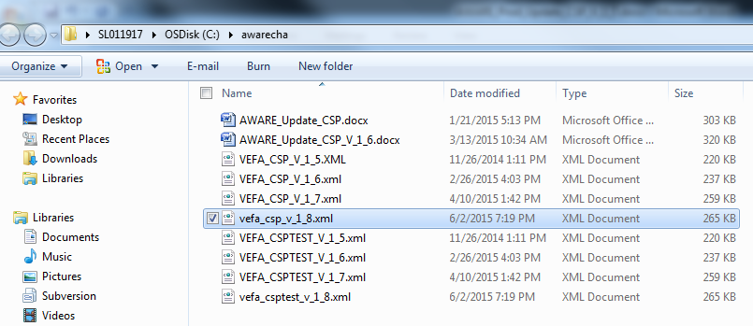

1. Click the **Open** button.

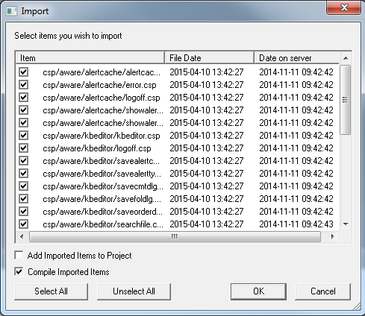

1. Verify the **Add Imported Items to Project** checkbox is not selected.
2. Click the **OK** button to import the KB Editor and Alert Cache Viewer CSP source files.